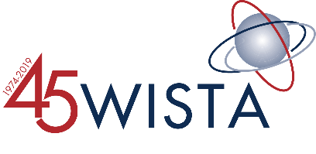
Formed in 1974, the Women’s International Shipping & Trading Association (WISTA International) is a global organisation connecting female executives and decision makers around the world. WISTA International serves as a connector for its network of more than 3,000 female professionals from all sectors of the maritime industry. WISTA International promotes increased competency and diversity throughout the maritime sector. WISTA International proudly cooperates with maritime organizations around the world, including: International Maritime Organization (IMO), International Chamber of Shipping (ICS), Institute of Chartered Shipbrokers (ICS), International Seafarers Welfare and Assistance Network (ISWAN), Intermanager, INTERTANKO, Women in Maritime Association (WIMA), Women in the Maritime Sector in East and Southern Africa (WOMESA). In 2017, WISTA International was awarded the Safety4Sea Sustainability Award and entered into an MOU with Institute of Chartered Shipbrokers (ICS) to award scholarships to females seeking diploma certification at ICS. In 2018, WISTA International became a consultative member of the International Maritime Organization (IMO).
Forty-seven countries support a National WISTA Association (NWA), each of which in turn is a member of and is guided by WISTA International. NWAs provide in-country and regional networking, business and skill building opportunities, corporate visibility, and also facilitate relationships within the industry. A list of the current NWAs can be found on our website: www.wistainternational.com.
Promoting WISTA International’s mission is the work of the committees. Each working committee is comprised of members from around the world. Currently, WISTA International has a Diversity Committee, a Futures & Technologies Committee, a Human Resources Committee and a Communications Committee. Committee work, responsibilities and members can be found on our website: https://wistainternational.com/committees/
WISTA International is guided by an Executive Committee, elected by the NWAs. The 2018-2019 WISTA International Executive Committee is comprised of WISTA International President, Despina Panayiotou Theodosiou (WISTA Cyprus); WISTA International Treasurer Connie Roozen (WISTA The Netherlands); WISTA International Secretary, Diane Edwards (WISTA New Zealand); WISTA International Board Member, Jeanne Grasso (WISTA USA); WISTA International Board Member, Sanjam Gupta (WISTA India); WISTA International Board Member, Naa Densua Aryeetey (WISTA Ghana); WISTA International Board Member, Angie Hartmann (WISTA Hellas). Full biographies of the WISTA Executive Committee can be found on our website: www.wistainternational.com.
For more information, please contact WISTA International Press Officer, Jillian Tobias at jillian@logonmediastrategies.com or +1-954-549-5175.

